ECE-161C MODEM DESIGN, SPRING 2021
MEDIUM LENGTH (BUT EASY) FINAL PROJECT
A MATLAB PROGRAMMING PROBLEM AND LEARNING OPPORTUNITY
A. Implement an OFDM Modulator as a 128 point scaled IFFT with 54 occupied frequency bins. In particular, bins –27-to-1 and +1 to +27, (bin 0 empty). Each bin is 16-QAM. The IFFT divides the output signal by 128 which is too much attenuation. You will have to scale the IFFT to set the peak amplitude of the time series to be in the amplitude range 0.5 to 1.0. The successive OFDM symbol time series formed at the output of the transform is separated by a guard interval of 32 zero valued samples located at the beginning of each OFDM symbol. In this part, the guard intervals do not contain cyclic prefaces. Form an OFDM packet composed of 100 OFDM symbols. In two out of three subplots plot the real part and imaginary part of the time signal spanning 4-symbol durations. In the third subplot plot the power spectrum of the time series formed by a windowed 2048 point FFT. Comment on the side lobe structure of the spectrum. Use a Kaiser window with beta equal to 8.3, a value chosen to obtain -60 dB stopband side lobes.
B. Demodulate the OFDM packet and in one subplot display the (time) overlaid real part of the successive transforms in the (frequency) constellation diagram when there is no channel distortion. The gain we used to scale the IFFT in the modulator must be removed as an attenuation in the FFT demodulator to keep the constellation points in the unit square. In the second subplot plot the constellation points from all frequency bins in the OFDM symbols.
C. Pass the 100 OFDM symbols in our packet through a channel with impulse response
[1 0 0.2 0 0 0 0 0 0 j*0.1 ]
Now repeat part B and demodulate the channel distorted received OFDM packet and in one subplot display the (time) overlaid real part of the successive transforms in the (frequency) constellation diagram when there is channel distortion. The gain we used to scale the IFFT in the modulator must be removed as an attenuation in the FFT demodulator to keep the constellation points in the unit square. In the second subplot plot the constellation points from all frequency bins in the OFDM symbols.
D. Replace the 32-sample guard interval with a 32 sample cyclic prefix taken from the last 32 samples of each OFDM symbol. Pass this new packet through the same channel. Now repeat part B and demodulate the channel distorted received OFDM packet and in one subplot display the (time) overlaid real part of the successive transforms in the (frequency) constellation diagram when there is channel distortion. The gain we used to scale the IFFT in the modulator must be removed as an attenuation in the FFT demodulator to keep the constellation points in the unit square. In the second subplot plot the constellation points from all frequency bins in the OFDM symbols.
E. Insert two long preambles to the beginning of the 100 symbol modulated packet formed with the 32 sample cyclic prefix. The long preamble is formed by random QPSK constellation points in all 52 occupied OFDM frequency bins. Perform the 128 point IFFT and append two copies of the 128 point IFFT. Then take the last 64 samples of the second copy and move it to be the double length cyclic prefix of the long preamble. This trick avoids any discontinuities in the double length preamble. Pass the long preamble through the channel. Demodulate the two 128 point sequences. Each bin of the 52 bins had a known input amplitude and phase when it left the modulator. We have measured the gain and phase of each bit at the output of the channel. The relationship between channel and received signal at each frequency is of the form Frcvd(K)=Fxmtd(k)* Fchannel(k). From this relationship we can estimate the channel and remove it from the received signal.
Form 2 subplots. In the first show the 128 point FFT magnitude spectrum of the channel, the magnitude spectrum of the long preamble, and the magnitude spectrum of the received symbol from the channel. In the second show the 128 point FFT magnitude spectrum of the channel and the channel estimate obtained from the long preamble.

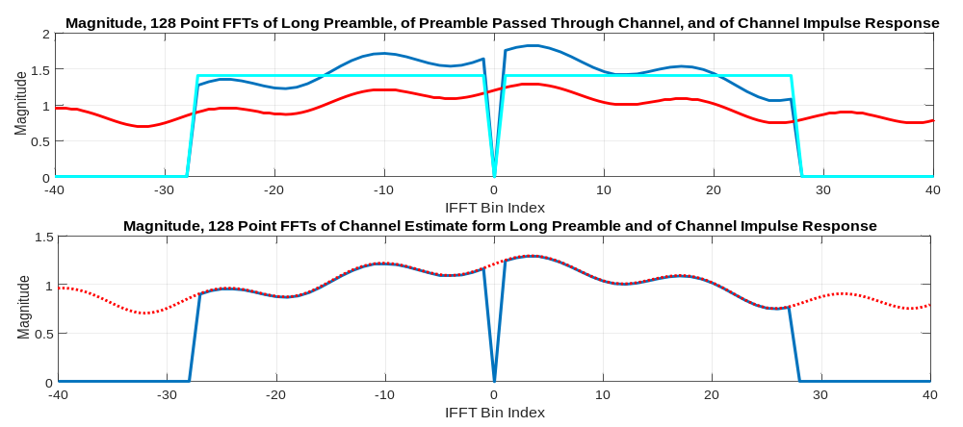

F. From here on, each successive symbol is received through the channel. We multiply each received constellation point by the inverse of the channel response at each frequency to obtain the equalized received constellation points. Apply the equalizer inverse channel gain to each received symbol and plot on two subplots plot the equalized time overlaid real part of the successive transforms in the (frequency) constellation diagram. The gain we used to scale the IFFT in the modulator must still be removed as an attenuation in the FFT demodulator to keep the constellation points in the unit square. In the second subplot plot the equalized constellation points from all frequency bins in the OFDM symbols.

G. Insert 50 samples of delay and a single OFDM symbol length preamble at the beginning of the OFDM packet formed by zero packing the spectrum 1-to-4. Only insert random QPSK data in bins ±4, ±8, ±12,...., ±24. This symbol also has an appended cyclic prefix. Add white noise of standard deviation 0.01 to the delay and preamble. Spin the data being delivered through the channel at 3 degrees per sample. Use a 32 sample delay line and form the cross correlation between input and output and form the autocorrelation at the output of the delay line. Take the ratio of the auto and cross correlation sequences. Verify that the sample by sample ratio of the cross to the auto correlation identifies the start of the OFDM signal. Present a figure showing magnitude of cross, auto, and ratio. Also show the angle obtained at the output of the 32 sample averager processing the cross correlation. Verify this is a reasonable estimate of the input rotation rate. Present a figure showing output of 32-point averager and the estimated rate of rotation. This estimated rotation rate would normally be used to de-spin subsequent signal samples following this short preamble. Since we did not include pilots in this project, we will not actually use the estimate to de-spin the input signal
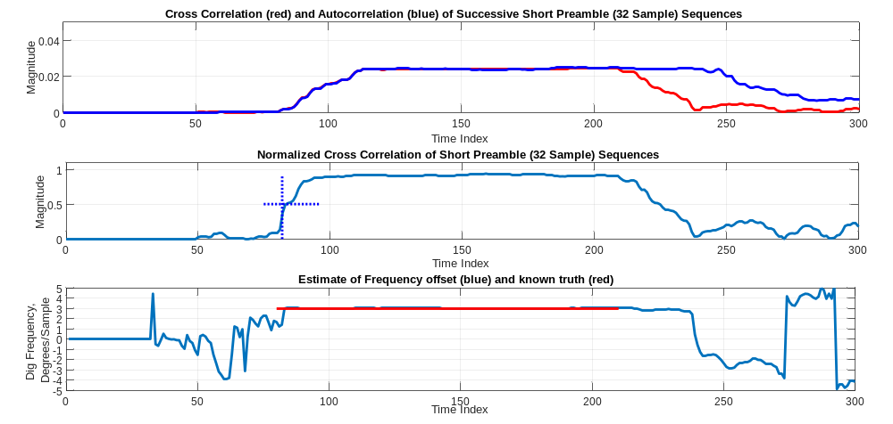

A bit of assistance follows

%40 MHz sample rate, 1/40 usec/sample, 160 samples/symbol, 4 usec duration
% 1/40 usec/sample, 128 samples/symbol, 3.2 usec transform segment
% spectral channel spacing 1/3.2 usec = 312.5 kHz
x0=[]; % empty array for OFDM with Guard interval
y0=[]; % empty array for OFDM with cyclic prefices
for k=1:100
fxx=zeros(1,128);
dat=(floor(4*rand(1,54))-1.5)/1.5+j*(floor(4*rand(1,54))-1.5)/1.5;
fxx(65+(-27:27))=[dat(1:27) 0 dat(28:54)];
xx=8*ifft(fftshift(fxx));
x0=[x0 zeros(1,32) xx];
y0=[y0 xx(97:128) xx];
end
figure(1)
subplot(2,1,1)
plot(0:640, real(x0(1:641)),'b','linewidth',2)
hold on
for k=1:160:640
plot(k:k+31,real(x0(k:k+31)),'r','linewidth',2)
end
hold off
grid on
set(gca,'XTick',[0:32:640])
axis([0 640 -1.2 1.2])
title('Real Part 128 Point OFDM Signal, with 32 Sample Guard Intervals')
xlabel('Time Index')
ylabel('Amplitude')
subplot(2,1,2)
plot(0:640, real(y0(1:641)),'b','linewidth',2)
hold on
for k=1:160:640
plot(k:k+31,real(y0(k:k+31)),'r','linewidth',2)
end
hold off
grid on
set(gca,'XTick',[0:32:640])
axis([0 640 -1.2 1.2])
title('Real Part 128 Point OFDM Signal, with 32 Sample Cyclic Prefices')
xlabel('Time Index')
ylabel('Amplitude')

figure(2)
subplot(2,1,1)
plot(0,0)
hold on
for n=1:160:16000-160
x1=x0(n:n+159);
fx1=fftshift(fft(x1(33:160)))/8;
plot(-64:63,real(fx1),'ro','linewidth',2,'markersize',6)
end
hold off
grid on
axis([-32 32 -1.5 1.5])
set(gca,'XTick',[-64:8:64])
title('Real Part, FFT Transform Segments of OFDM Symbols')

subplot(2,1,2)
plot(0,0)
hold on
for n=1:160:16000-160
x1=x0(n:n+159);
fx1=fftshift(fft(x1(33:160)))/8;
plot(fx1,'ro','linewidth',2,'markersize',6)
end
hold off
grid on
axis('equal')
axis([-1.5 1.5 -1.5 1.5])

